**Ex:11 PL SQL PROGRAMS**

PROGRAM 1

Write a PL/SQL block to calculate the incentive of an employee whose ID is 110.

|  |
| --- |
| declare a  employees.employee_id%type; b employees.salary%type; begin  Select salary into a from employees where employee_id = 110; b:=0.05*a; dbms_output.put_line('Salary after incentive : '||(a+b)); end; |

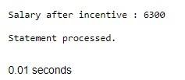

PROGRAM 2

Write a PL/SQL show an invalid case-insensitive reference to a quoted and without quoted user-defined identifier.

declare non_quoted_variable varchar2(10) := 'Hi'; "quoted_variable" varchar2(10) := 'Hello'; begin

dbms_output.put_line(NON_QUOTED_VARI ABLE);

dbms_output.put_line("quoted_variable"); dbms_output.put_line("QUOTED_VARIABLE

"); end;

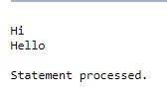

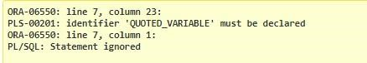

PROGRAM 3

Write a PL/SQL block to adjust the salary of the employee whose ID

122. Sample table: employees

|  |
| --- |
| declare old_salary employees.salary%type; new_salary  employees.salary%type; begin  new_salary:= :sal;  Select salary into old_salary from employees where employee_id = 122; dbms_output.put_line('Before updation: '||old_salary);  Update employees set salary = salary + new_salary where employee_id = 122; Select salary into new_salary from employees where employee_id = 122; dbms_output.put_line('After updation: '||new_salary); end; |

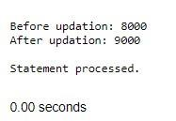

PROGRAM 4

Write a PL/SQL create a procedure using the "IS [NOT] NULL Operator" and show AND operator returns TRUE if and only if both operands are TRUE.

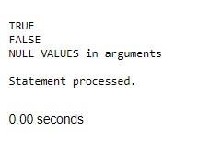

PROGRAM 5

Write a PL/SQL block to

|  |
| --- |
| Create or replace procedure proc1( a boolean, b boolean) IS  BEGIN  if(a is not null) and (b is not null) then if(a = TRUE and b = TRUE) then dbms_output.put_line('TRUE'); else dbms_output.put_line('FALSE'); end if; else  dbms_output.put_line('NULL VALUES in arguments'); end if; end proc1;  BEGIN  proc1(TRUE,TRUE); proc1(TRUE,FALSE); proc1(NULL,NULL);  end; |

describe the usage of LIKE operator including wildcard characters

and escape character.

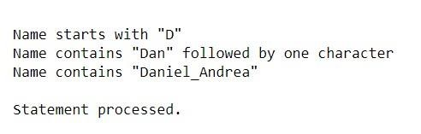

|  |
| --- |
| Declare name varchar2(20); num number(3); Begin num := :n;  Select first_name into name from employees where employee_id=num; if name like 'D%' then  dbms_output.put_line('Name starts with "D"'); end if;  if name like 'Dan_el%' then dbms_output.put_line('Name contains "Dan" followed by one character'); end if;  name := 'Daniel_Andrea'; if name like 'Daniel\_Andrea' escape '\' then dbms_output.put_line('Name contains  "Daniel_Andrea"'); end if; end; |

PROGRAM 7

Write a PL/SQL PROGRAM 6

Write a program to arrange the number of two variable in such a way that the small number will store in num_small variable and large number will store in num_large variable.

|  |
| --- |
| declare a number(2); b number(2); num_small number(2); num_large number(2);  begin a := :s; b := :l; dbms_output.put_line('Value in a : '||a); dbms_output.put_line('Value in b : '||b); if a>b then num_small := b;  num_large := a; else num_small :=a; num_large :=b;  end if; dbms_output.put_line('Smaller number is '||num_small); dbms_output.put_line('Larger number is '||num_large); end; |

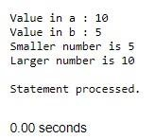 procedure to calculate the incentive on a target achieved and display

the message either the record updated or not.

PL/SQL

|  |
| --- |
| Create or replace procedure calc_incen(emp_id number,achievement number,target number)  AS  incentive number; rowcount number; Begin if achievement > target then incentive:= achievement*0.2; else incentive:=0; end if;  Update employees set salary = salary + incentive where employee_id = emp_id; rowcount:= SQL%ROWCOUNT; if rowcount>0 then  dbms_output.put_line('Record(s) updated'); else dbms_output.put_line('No Record(s) updated'); end if; end;  Declare id number; achievement number; target number; Begin id := :emp_id; achievement  := :achieve; target :=  :target_;  calc_incen(id,achievement,target); end; |

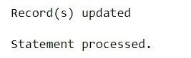

PROGRAM 8

Write a procedure to calculate incentive achieved according to the specific sale limit.

PROGRAM 9

Write a PL/SQL

|  |
| --- |
| Create or replace procedure calc_incen(emp_id number,sales number) AS incentive number; rowcount number; Begin if sales < 1000 then incentive:= 0; elsif sales > 1000 and sales < 2000 then incentive := sales * 0.2; else incentive := sales  * 0.5; end if;  Update employees set salary = salary + incentive where employee_id = emp_id; rowcount:= SQL%ROWCOUNT; if rowcount>0 then  dbms_output.put_line('Record(s) updated'); else dbms_output.put_line('No Record(s) updated'); end if; end;  Declare id number; sales number; sal number; Begin id := :emp_id; sales := :sale;  select salary into sal from employees where employee_id = id; dbms_output.put_line('Before incentive calculation: '||sal); calc_incen(id,sales); select salary into sal from employees where employee_id = id; dbms_output.put_line('After incentive calculation: '||sal); end; |

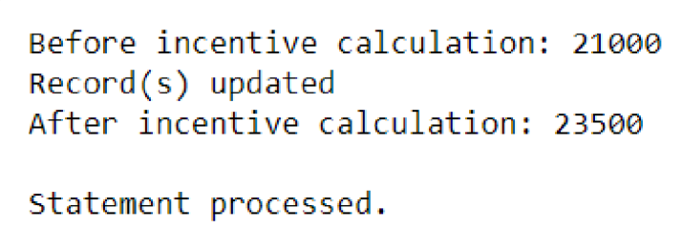

count number of employees in department 50 and check whether this department have any vacancies or not. There are 45 vacancies in this department.

|  |
| --- |
| declare emp_count number; vacancy number := 20; begin  Select count(*) into emp_count from employees where department_id = 10; dbms_output.put_line('Total seats : '||vacancy); dbms_output.put_line('Number of employees in Department 50 : '||emp_count); if emp_count>vacancy then dbms_output.put_line('No vacancies available'); else  dbms_output.put_line('Available vacancies : '||(vacancy-emp_count)); end if; end; |

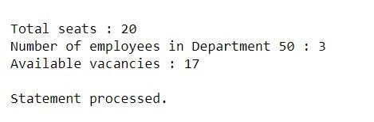

PROGRAM 11

Write a PL/SQL program to display the

count number of employees in a specific department and check

whether this department have any vacancies or not. If any vacancies, how many vacancies are in that department.

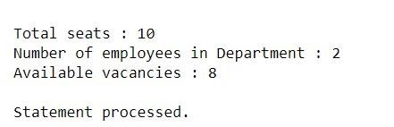

Write a PL/SQL program to display the

|  |
| --- |
| declare dept_id number; emp_count number; vacancy number := 10; begin  dept_id := :id;  Select count(*) into emp_count from employees where department_id = dept_id; dbms_output.put_line('Total seats : '||vacancy); dbms_output.put_line('Number of employees in Department : '||emp_count); if emp_count>vacancy then dbms_output.put_line('No vacancies available'); else  dbms_output.put_line('Available vacancies : '||(vacancy-emp_count)); end if; end; |

employee IDs, names, job titles, hire dates, and

salaries of all employees.

begin for i in (select employee_id, first_name, job_id, hire_date, salary from

employees) loop dbms_output.put_line('employee id: ' || i.employee_id); dbms_output.put_line('name: ' || i.first_name); dbms_output.put_line('job title: ' || i.job_id); dbms_output.put_line('hire date: ' || to_char(i.hire_date, 'dd-monyyyy')); dbms_output.put_line('salary: ' || i.salary); dbms_output.put_line('------------------------------'); end loop; end;

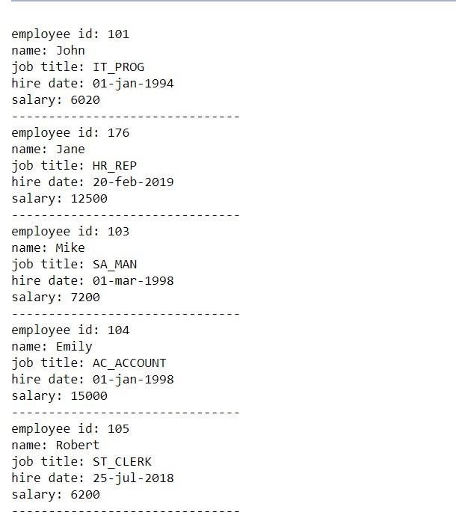

Write a PL/SQL program to display the employee IDs, names, and department names of all

employees.

begin for i in (select e.employee_id, e.first_name, e.job_id from employees e) loop dbms_output.put_line('employee id: ' ||

i.employee_id); dbms_output.put_line('name: ' || i.first_name); dbms_output.put_line('department name: ' || i.job_id);

dbms_output.put_line('-------------------------------'); end loop; end;

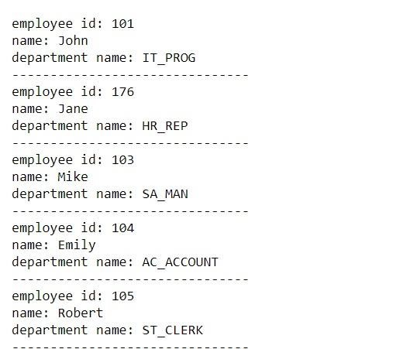

program to display the

PROGRAM 13

Write a job IDs, titles, and minimum salaries of all jobs.

|  |
| --- |
| Begin for i in (select job_id,job_title,min_salary from jobs)  loop  dbms_output.put_line('job id: ' || i.job_id);  dbms_output.put_line('job title: ' || i.job_title); dbms_output.put_line('minimum salary: ' || i.min_salary);  dbms_output.put_line('-------------------------------'); end  loop; end; |

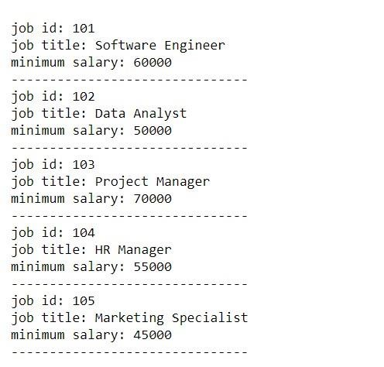

PL/SQL program to display the

PROGRAM 14

Write a PL/SQL employee IDs, names, and job history start dates of all employees.

Begin

for i in (select employee_id,employee_name,start_date from

job_history) loop dbms_output.put_line('employee id: ' ||

i.employee_id); dbms_output.put_line('name: ' || i.employee_name); dbms_output.put_line('start date: ' ||to_char(i.start_date, 'dd-monyyyy')); dbms_output.put_line('-------------------------------'); end loop; end;

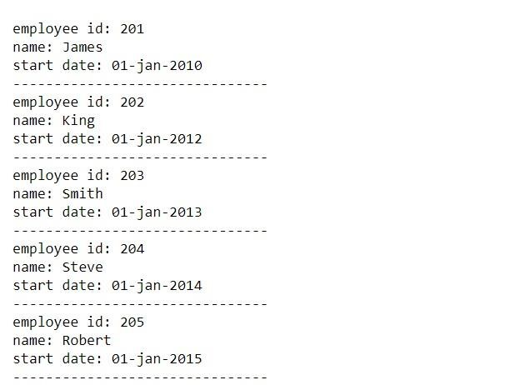

PROGRAM 15

Write a PL/SQL program to display the employee IDs, names, and job history end dates of all employees.

Begin for i in (select employee_id,employee_name,end_date from job_history)

|  |
| --- |
|  |

loop dbms_output.put_line('employee id: ' || i.employee_id); dbms_output.put_line('name: ' || i.employee_name); dbms_output.put_line('end date: ' ||to_char(i.end_date, 'dd-mon-yyyy')); dbms_output.put_line('-------------------------------'); end loop; end;

